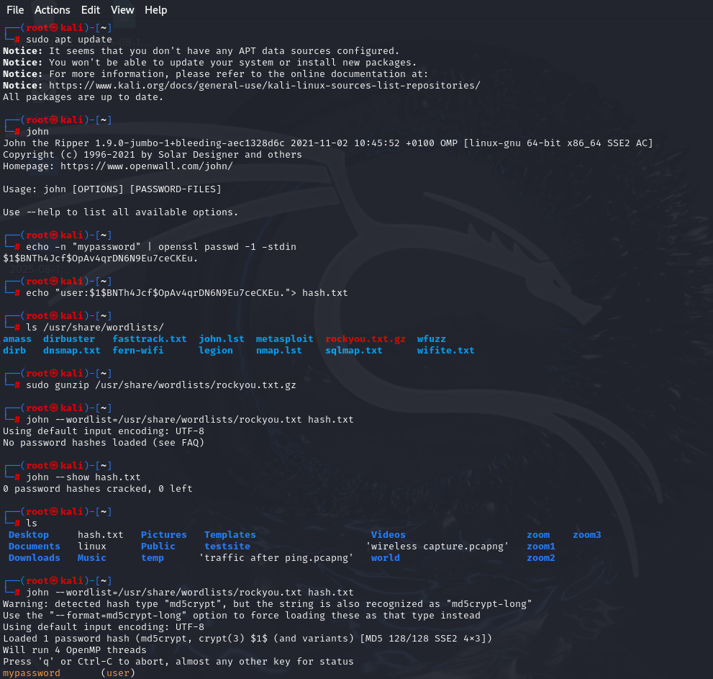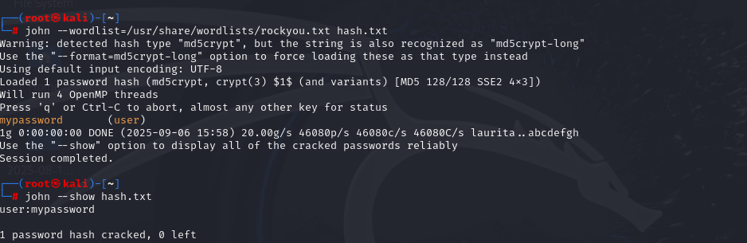

echo -n "mypassword" prints the word *mypassword* without a newline.

The pipe (|) sends it to **OpenSSL**.

openssl passwd -1 -stdin generates an **MD5 crypt hash**

"user:hashvalue" mimics how Linux /etc/shadow stores credentials

rockyou.txt.gz, unzip it using gunzip.rockyou.txt.gz command

john runs the tool.

--wordlist=... tells John to use the wordlist for testing passwords.

hash.txt is the file with your test hash.

--show displays results in username:password format.